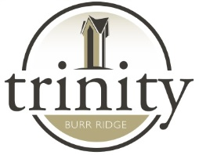
Hot Lunch 2019-2020

What is served? For the 2019-20 school year, we’ve contracted with Zazzo’s in Willowbrook as our Hot Lunch provider
How much does hot lunch cost? The prices depend on the food selected. Generally, prices for a lunch range from $4.00-$5.00 for an entrée, 1 healthy snack, and 1 fun snack. Milk will be around $ .40.
How is lunch served? Trinity Preschool and Kindergarten students come to the kitchen with a helper. 1st-8th grade students walk through the kitchen to receive their meals and eat in their classrooms.
How do I order? All ordering is done online via the Fast-Direct website. Below your email message, there is a button that says View Open Pre-Orders. This is where you can order during the period-of-time ordering is open
How do I pay? All orders are paid for through the main office by cash, check, or credit card (over$25).
How do I know what I’ve ordered? You can check your order on the Fast-Direct website.
Can I cancel an order? No. Once the deadline for ordering is past, no changes may be made. Numbers are tallied and given to the lunch and milk providers the next day for the entire month.
How can I volunteer? Trinity parents can volunteer to serve hot lunch. We will need someone to help set up and distribute the lunches every school day. You will earn a monetary credit each time you volunteer to serve lunch . Please let the school office know if you can help on a weekly basis!
What if I need help? Please contact the school office if you have any questions.

